Computer Language Coding Concepts

System Interface of a Related List Item
When you open up the system interface for a Related List Item, you get to see the system commands that apply to Related List Items. Aspects, that apply to a Related List Item are:

- Reference
- Object
- Existance
- Class
- List

Those are the same as a Related Item, minus the Name aspect, plus the List aspect.

Only the List aspect for the Related List Item is explained here. The other aspects were already worked out in the article System Interface for Related Item.

Related List Item’s List Aspect in the System Interface
The List aspect of the Related List Item is represented by:

- Remove
The command, which removes the item from the list
- List
A reference to the List that the Related Item it is part of.

The members are placed inside an interface, that wraps together the members of the List aspect:

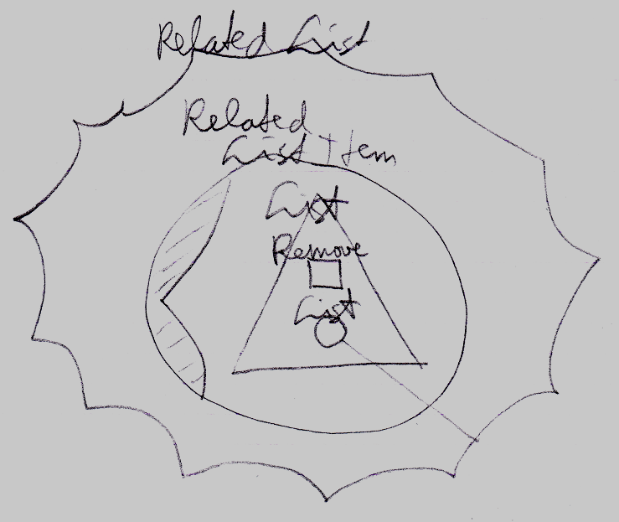

The Full System Interface for Related Item
A Related List Item is almost the same as a Related Item, so the full system interface of a Related List Item also shows all the other aspects:

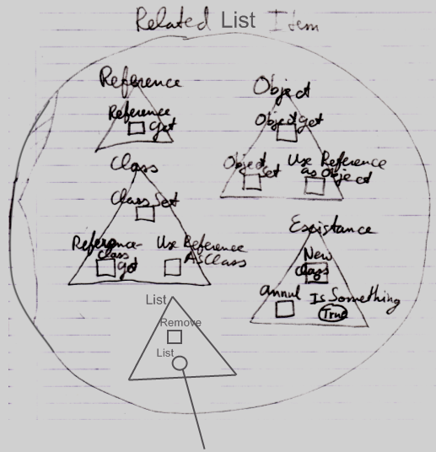

Author & Copyright: Jan-Joost van Zon Date: August 27, 2009 – August 27, 2009 Location: Oosterhout, The Netherlands Status: Finished

